Q-1. Deploy a website on localhost using either apache2 or Nginx. Create a DNS name for this website as ‘awesomeweb’. You can use any web template you want or can write your own simple HTML code.

-Deployed a website on localhost using Nginx:

sudo apt-get install nginx

sudo apt-get update

sudo service nginx start

* * Starting nginx nginx

sudo service nginx status

* * nginx is running

cd /var/www/html

ls

-> index.nginx-debian.html

sudo rm -rf index.nginx-debian.html

Created index.html file at /var/www/html

touch index.html

Website is running successfully on localhost.

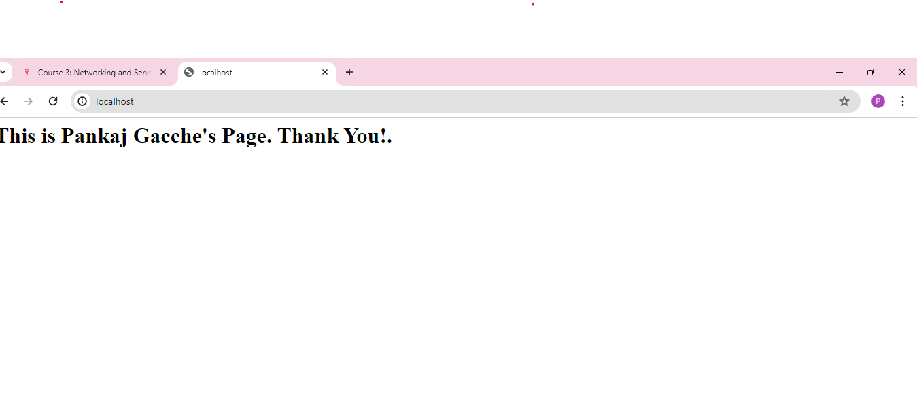

-Created a DNS name for this website as ‘awesomeweb’:

-Created ‘awesomeweb’ DNS name in host file.

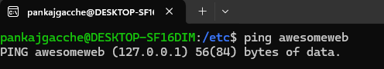



Q-2. A website can have many subdomains and different services are running on them. Write a Python script to check the status of the subdomains which are up or down. The script should automatically check the status every minute and should update it in tabular format on the screen.

-Written python script to check the status of the subdomains which are up or down and pushed .py file in github repository - https://github.com/PankajGacche/Networking_Assesment.git

-Created crontab which will execute python script every minute and validate subdomain availability and capture log and outpur in tabular format as below:

Output:

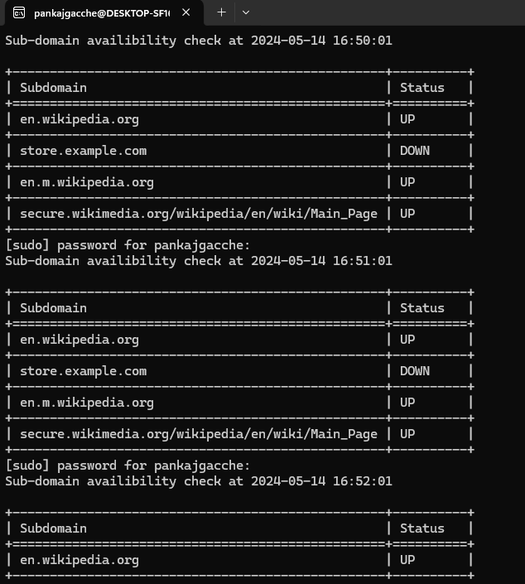

Logs:

